Lab day 1

2-

cat Command: Display the entire contents of one or more files.

Outputs entire content at once, can concatenate files, non-interactive.

more Command

View the contents of a file one screen at a time.

Paginated viewing, interactive navigation.

Differences

cat displays entire content at once, non-interactive.

more displays content page by page, interactive.

3-

rm Command

: Removes (deletes) files and directories

- rm -r directory removes the directory and its contents

- Can remove individual files, multiple files, or directories with contents using -r.

rmdir Command

: Removes empty directories.

- Only removes directories that are completely empty.

- Will not remove directories with contents

4-

cd ~

mkdir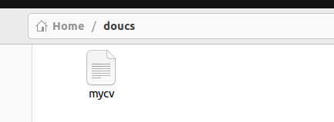 dir1/dir11

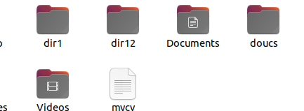

mkdir dir1/dir12

mkdir docs

touch dir1/dir11/file1

touch docs/mycv

-5

rmdir dir1/dir11

: it will fail because rmdir only works on empty directories.

rm -r dir1/dir11

: it will remove

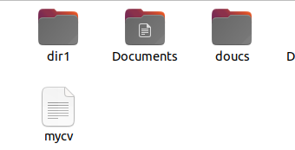6-

rmdir -p dir12

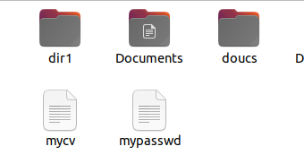

7-

cp /etc/passwd ~/mypasswd

8-

mv ~/mypasswd ~/oldpasswd

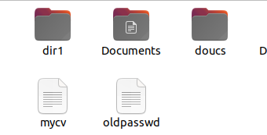

9-

/home/user/doce/mycv

**Absolute Path:** /home/user/ dose/mycv

**Relative Path:** mycv

--------------10

1-cd /home/user

2-cd ~

3-cd ..

Cd

cd /home/user

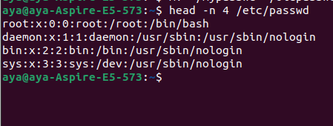-11

